Exercise 1 Circle the correct answer.

mom / dad
dad/grandpa
sister /brother

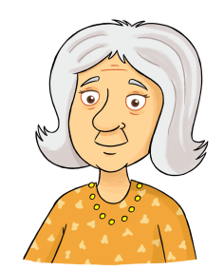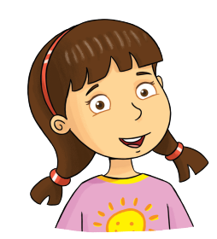
grandma/grandpa
brother /sister
grandma/ mom

Exercise 2 Look and write :
He | She

_____ is my dad.
She is my mom.
_____ is my grandma.

_____ is my brother.
_____ is my grandpa.
_____ is my sister.

Exercise 3. Look at the pictures and write.
 | a) Who is this ? | This is my sister
 | b) Who is this ? | …………………………………………..
 | c) Who is this ? | …………………………………………..
 | d) Who is this ? | …………………………………………..
 | e) Who is this ? | …………………………………………..
 | f) Who is this ? | …………………………………………..
Exercise 4. Look and tick or cross
a) This is my grandpa. b) This is my mom. c ) This is my sister.
a) This is my grandma. b) This is my dad. c ) This is my sister.
Exercise 5. Look and match
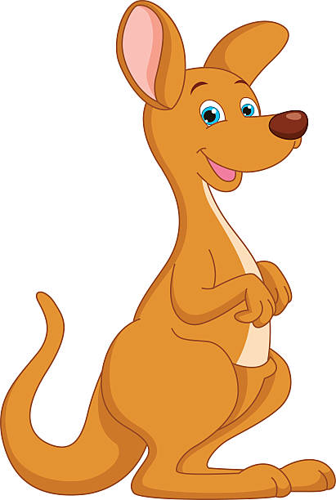
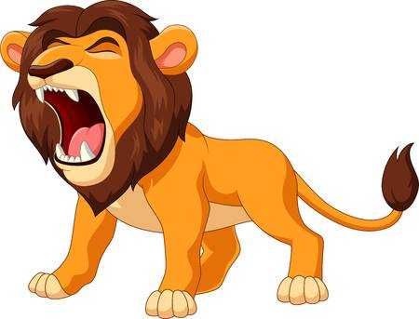

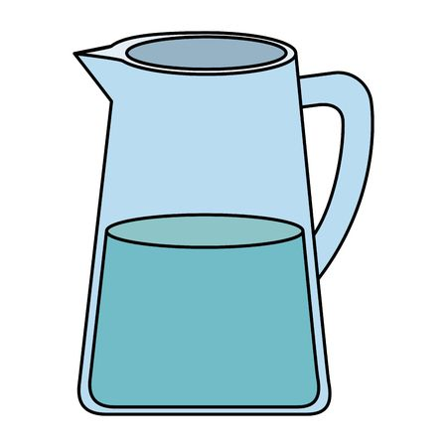


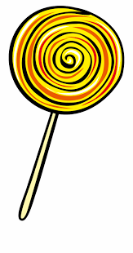
Jj

Kk

Ll

Exercise 6. Look and write the missing letters.

 |  | 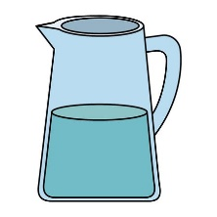
_ io _ | _ uice | _ _ _
 | 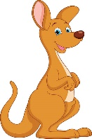
_ e_ | kangar _ _ | _ _llipop

Exercise 7.Circle the correct answer.

 | - I like juice / lollipop.
 | - It is a ball / key.
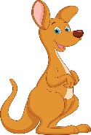 | - It is a kangaroo/lion
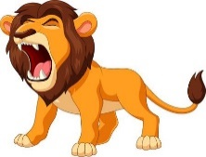 | - It is a cat / lion.
 | - I like juice / lollipop.
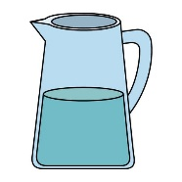 | - It is a jug /key.

